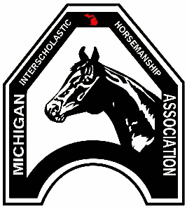 | Criminal Sexual Conduct  Michigan Interscholastic Horsemanship Association

District:

By signing below, I confirm that on (date) __________________ I performed Criminal Sexual Conducts on all registered coaches, assistant coaches, and adult volunteers for the __________ season.

Name | School | Position | Status

Print Name:
Signature:

